Kingdom of the Winds Remake — Game Design Plan
Oct 29, 2026 · @James Jeon

Vision and pillars
Build a 2D, tile-based online RPG that recaptures how 1990s 바람의 나라 felt: pixel art, simple movement, four interdependent classes, and a town where everyone gathers.
- Feel over fidelity. Match the mood (grid movement, ghost-on-death, shouting in the town square), not the exact content.
- Social first. Parties, chat, trading and guilds matter more than solo content.
- Simple controls, real roles. Easy to move and fight; a party still needs its healer and its tank.
- Built to grow. Start with one map offline, then add networking, then more world.

Scope and roadmap
Go from an offline prototype to a small online alpha in four phases, and only move on when the current phase passes its play test.
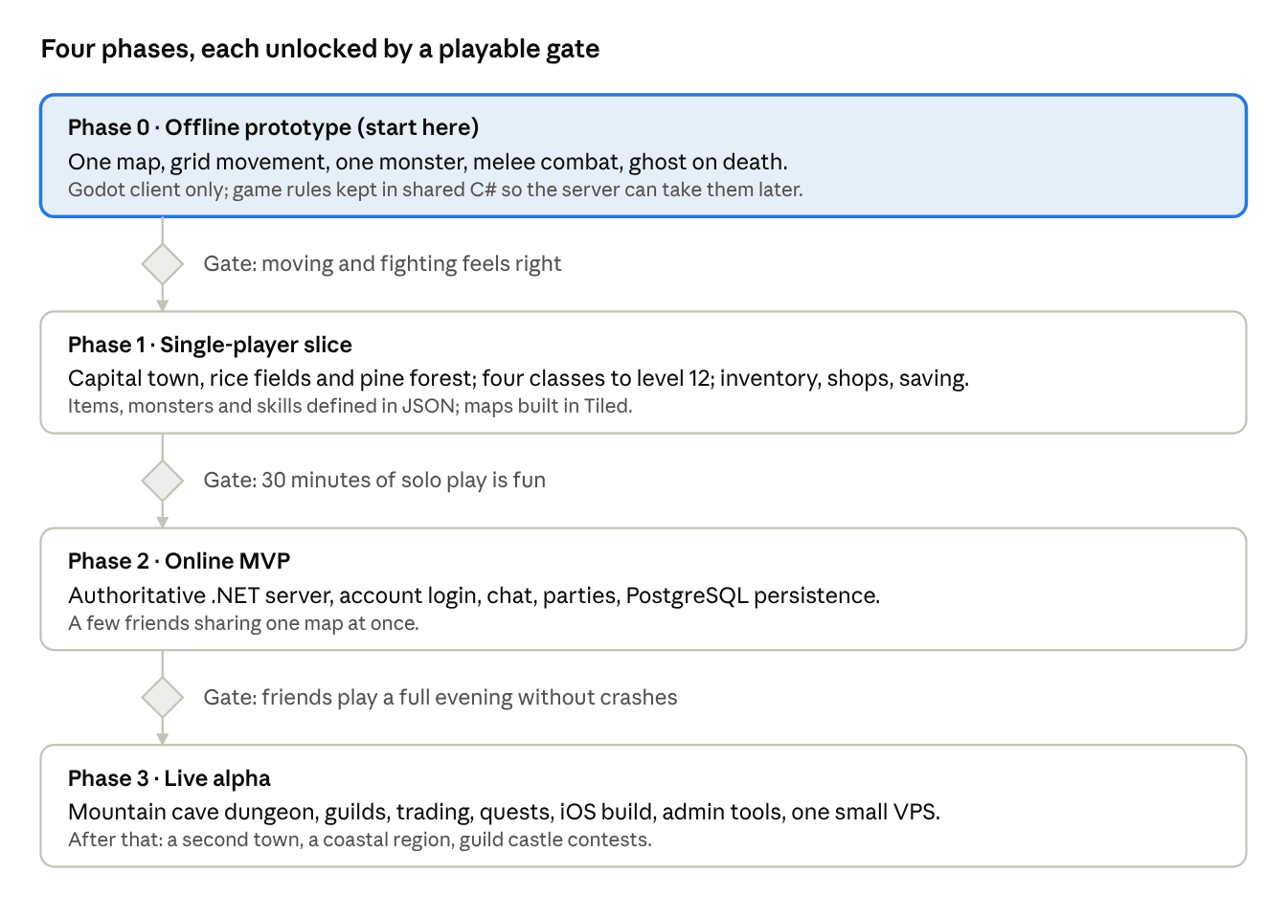
roadmap · 4 phases, 3 gates
Networking waits until Phase 2 on purpose: the game has to be fun with one player before it's worth making it multiplayer.

Setting and world
An original kingdom inspired by the early Three Kingdoms of Korea (around the 1st century): walled towns, mountain shrines, river valleys and forests full of spirits from Korean folklore. Every place name is invented; real history only sets the flavor.
The first playable world is one hub town plus three hunting areas, laid out so players walk outward as they level.
Zone | Levels | Purpose
Capital town | All | Hub: inn (spawn), blacksmith, herbalist, shrine (resurrect), storage, job masters
Rice fields outside the gate | 1–5 | Rabbits, rats, squirrels; learn movement and combat
Pine forest | 5–12 | Foxes, wolves, wild boars; first party play
Mountain cave | 12–20 | First dungeon with a boss spirit; needs a healer
Later: a second town, a coastal region, a castle that guilds can contest.

Core gameplay
Players start classless, pick one of four paths at level 5 from a job master in town, then grind, party up and gear up toward the cave boss.

Classes
Class | Role | Signature skills
Warrior | Tank, melee damage | Taunt, heavy strike, high HP
Rogue | Burst melee, evasion | Backstab, poison, short stealth
Mystic | Ranged magic, area damage | Fire, ice and lightning spells; paralyze
Monk | Healer, support | Heal, buffs, resurrect fallen players

Combat
- Grid movement. Characters move tile by tile in four directions and face where they last moved.
- Melee hits the tile you face (attack key or auto-attack on bump).
- Spells use number-key hotbars, cost mana and need a selected target (Tab to cycle).
- Death turns you into a ghost who can walk to the shrine or wait for a Monk's resurrect. Small EXP loss.

Progression and items
- EXP from monsters and quests; levels raise HP, MP and stat points.
- Stats: Strength, Dexterity, Intelligence, Wisdom, Constitution.
- Gear slots: weapon, armor, helmet, shield, two rings, necklace.
- Items come from drops and NPC shops; gold is the only currency at first.

Social
- Chat: local, whisper, shout (whole map), party.
- Party of up to 5 with shared EXP.
- Player-to-player trade window.
- Guilds and a guild chat channel in the live alpha.

Art, audio and UI
Top-down pixel art on a 32×32 tile grid, rendered at a low internal resolution and scaled up with nearest-neighbor filtering so it stays crisp.
- Sprites: 4 directions × idle, walk (3–4 frames) and attack (2–3 frames). Paper-doll layers (body, hair, armor, weapon) so gear shows on the character.
- Art sources: placeholder packs first (itch.io has East-Asian themed tilesets), then commissioned or self-drawn art in Aseprite once the game is fun.
- Audio: royalty-free or commissioned tracks with Korean traditional instruments (gayageum, daegeum, janggu); short retro sound effects.
- PC UI: status panel with HP/MP bars, chat box at the bottom, inventory and skill windows that open with hotkeys.
- Mobile UI: virtual D-pad on the left, attack and 4–6 skill buttons on the right, chat collapsed by default.

Technical architecture
Use C# end to end (Godot 4 client, .NET server, one shared library) so your existing .NET and PostgreSQL skills carry the whole stack.
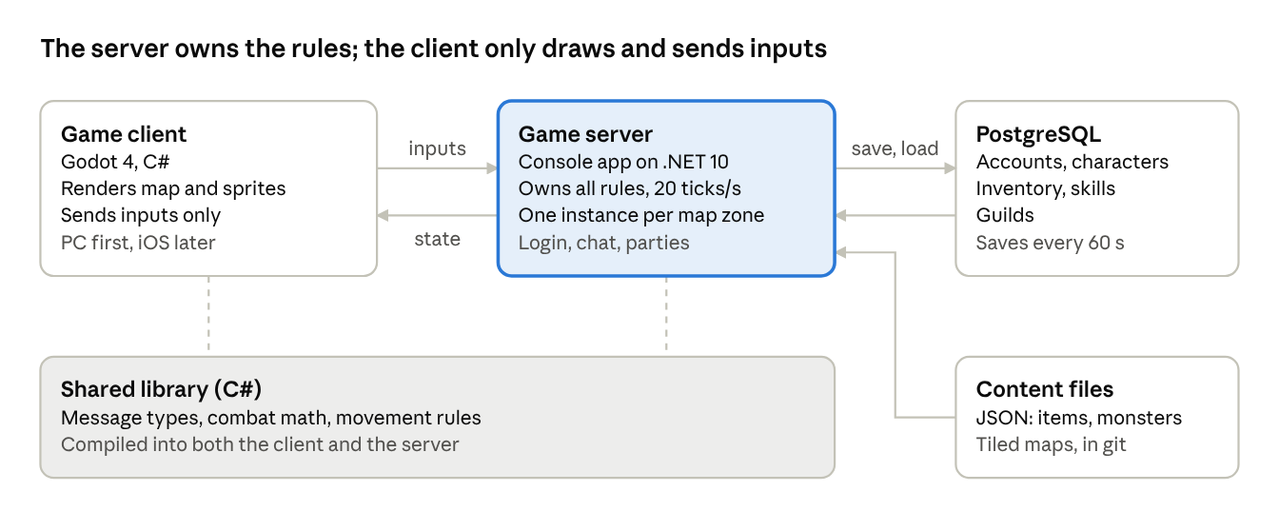
architecture · client, server, shared library, data
The client never decides outcomes: it sends key presses, and the server sends back positions, damage and drops, which blocks most cheating. Content files ship with the client too, so both sides agree on item and monster stats.
Piece | Choice | Why
Engine | Godot 4, .NET edition | Free, strong 2D tilemaps, C# scripting
Networking | LiteNetLib (reliable UDP) | Lightweight, pure C#, works on both sides
Serialization | MessagePack for C# | Small, fast binary messages
Database access | Npgsql + Dapper | Plain SQL you already know
Map editor | Tiled | Industry standard for 2D tile maps
Pixel art | Aseprite | Sprite sheets and animation
Hosting | Docker on one small VPS | Cheap until real players arrive
Fallback if Godot's C# iOS export is not good enough: Unity, with the same server and shared library.

Data model sketch
Player state lives in PostgreSQL; static game content (items, monsters, skills, maps) lives in versioned JSON and Tiled files in the repo, referenced by string IDs.
Table | Key columns | Notes
accounts | id, email, password_hash, created_at | Login only; no game state
characters | id, account_id, name, class, level, exp, map_id, x, y, facing | Name unique; class null until level 5
character_stats | character_id, str, dex, int, wis, con, hp, mp, unspent_points | One row per character
inventory_items | id, character_id, item_def_id, slot, quantity, equipped_slot | item_def_id points at content JSON
learned_skills | character_id, skill_def_id, hotbar_slot | Composite key
guilds | id, name, leader_id, created_at | Live alpha
guild_members | guild_id, character_id, rank | Live alpha
The server saves on logout, on map change and every 60 seconds, so a crash loses at most a minute.

Milestone 1: offline prototype
Goal: one character walking around one map and fighting one monster, with the right grid-movement feel. No networking yet, but code is split so the server can take over game logic later.
- ☐ Install Godot 4 (.NET edition) and the .NET SDK; create a repo with client/, server/ and shared/ folders
- ☐ Settle tile size (32×32) and internal resolution; drop in a placeholder tileset and character sprite
- ☐ Draw the rice-field map in Tiled and import it into Godot
- ☐ Tile-by-tile 4-direction movement with walk animation and collision
- ☐ Camera follows the player
- ☐ One monster (rabbit) that wanders, chases when hit and attacks
- ☐ Melee attack on the faced tile, HP, damage numbers, monster death and respawn
- ☐ Player death as a ghost, revive at a shrine tile
- ☐ Minimal HUD: HP/MP bars and a chat box stub
- ☐ Put combat math and movement rules in shared/ as plain C#, not in Godot scripts

Open questions and risks
- ☐ PC first or iOS first? The plan assumes PC first for faster iteration, iOS from the live alpha. - PC web app
- ☐ Godot or Unity? Godot is free and light for 2D; check how mature its C# iOS export is before committing. Unity is the fallback. - Godot
- ☐ Private hobby or public release? Public release raises the bar on original art, music and naming. - private hobby
- ☐ Art budget: self-drawn, asset packs or commissions? - AI generated arts
- ☐ Final title and kingdom name. - Kingdom of the Winds
Risks
- Scope creep. MMOs never end; each phase gate has to be met before starting the next.
- Cheating. The server must own all game rules; the client only sends inputs.
- Running costs. Start on one small VPS and only scale when real players show up.
- Solo time. Keep milestones to 2–4 weeks of evenings so progress stays visible.

